Lab 1 : Creating Custom Cortex Code Skills in Snowsight

Table of Contents
Introduction 3
Learning Objectives 3
Prerequisites 3
Part 1 — Preparing the Target Data 4
Step 1 — Create the Database and Table 4
Step 2 — Insert Mock Billing Data 5
Part 2 — Preparing the Workspace Directory 6
Step 1 — Open a Snowsight Workspace 6
Step 2 — Create the Skill Hierarchy 6
Part 3 — Authoring the Skill Specification 7
Step 1 — Create the Skill File 7
Step 2 — Define the Agent Instructions 7
Part 4 — Invoking the Skill in Cortex Code 8
Step 1 — Open the Cortex Code Panel 8
Step 2 — Trigger the Skill 8
Step 3 — Interact with the Agent 8
Knowledge Check 10
Clean Up 10
Troubleshooting 11
Symptom: The /cost-intelligence skill does not appear when I type / in the chat. 11
Symptom: The agent says it cannot find the WAREHOUSE_METRICS table. 11
Conclusion 11

Introduction
Snowflake Cortex Code (CoCo) is an AI-powered coding agent that understands your data context. While it is highly capable out-of-the-box, its real power lies in Agent Skills. Skills are modular, declarative workflows that encapsulate domain expertise—turning a generic AI assistant into a specialized tool for your organization.
In this lab, you will author a Custom Skill directly in the Snowsight UI. First, you will provision a mock FinOps database to ensure the agent has data to analyze. Then, you will create the required workspace directory structure, author a SKILL.md specification file for a Cost Intelligence persona, and invoke the skill interactively using the Cortex Code chat panel.

Learning Objectives
Upon completing this lab, you will be able to:
- Provision target databases and mock data for agent analysis.
- Navigate the Snowsight Workspace file system to manage AI assets.
- Create the mandatory directory hierarchy (.snowflake/cortex/skills) for personal skills.
- Author a declarative .md skill file that defines agent instructions and guardrails.
- Invoke and test a custom skill natively inside the Snowsight Cortex Code chat interface.

Prerequisites
Before starting, ensure you have:
- Access to a Snowflake Enterprise (or higher) account.
- A role with CREATE DATABASE privileges (e.g., SYSADMIN).
- The SNOWFLAKE.CORTEX_USER or SNOWFLAKE.CORTEX_AGENT_USER database role granted to your user.
- A basic understanding of navigating the Snowsight UI.

Part 1 — Preparing the Target Data
Before we can ask an AI agent to analyze costs, we must provide it with data. We will create a mock FinOps database representing daily warehouse credit consumption.

Step 1 — Create the Database and Table
Open a new SQL Worksheet in Snowsight and execute the following commands.
USE ROLE SYSADMIN;
CREATE OR REPLACE DATABASE enterprise_finops_db;
CREATE OR REPLACE SCHEMA billing;
CREATE OR REPLACE TABLE warehouse_metrics (
warehouse_name VARCHAR,
credits_used FLOAT,
usage_date DATE
);
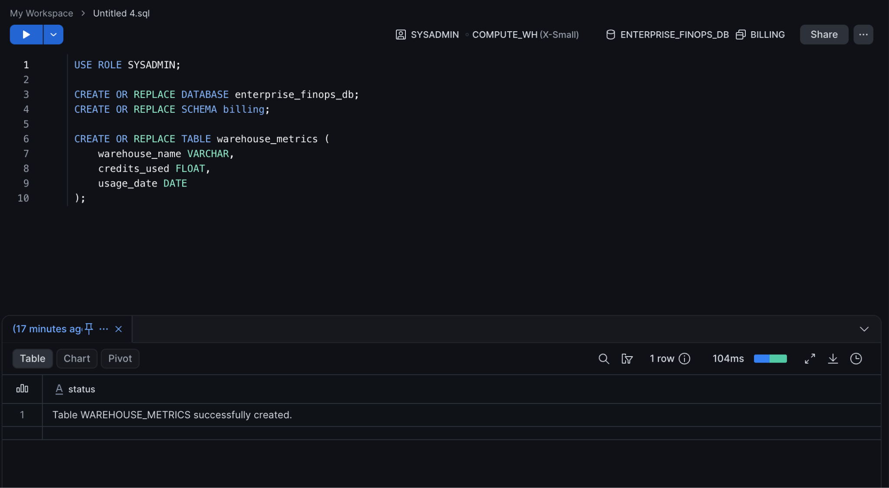

Expected Output:
Table WAREHOUSE_METRICS successfully created.

Step 2 — Insert Mock Billing Data
Execute the following insertion script to populate the table with sample credit usage(select database we created earlier).
INSERT INTO warehouse_metrics (warehouse_name, credits_used, usage_date) VALUES
('COMPUTE_WH', 45.5, CURRENT_DATE()),
('ETL_HEAVY_WH', 320.0, CURRENT_DATE()),
('REPORTING_WH', 12.5, CURRENT_DATE()),
('DATA_SCIENCE_WH', 150.75, CURRENT_DATE());
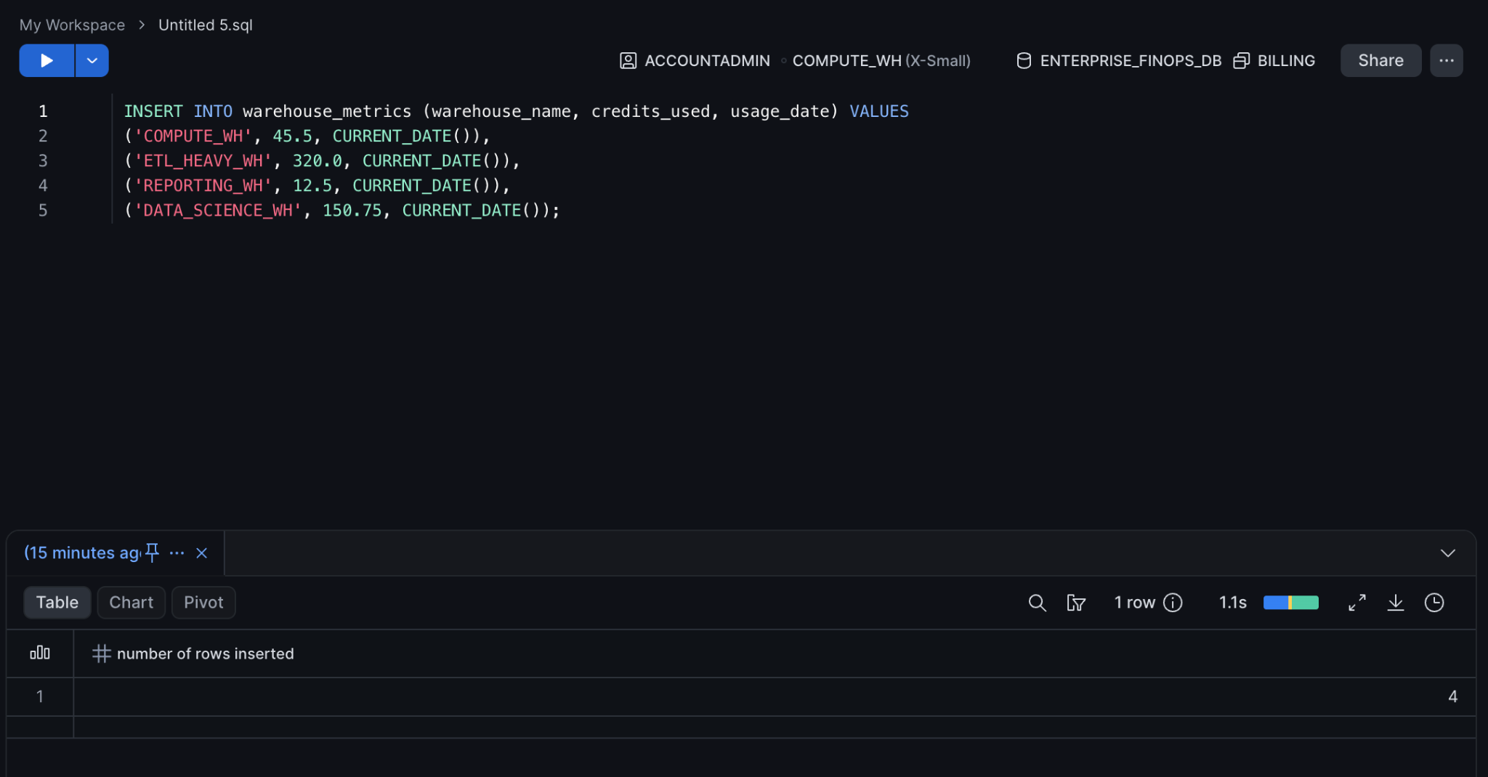
Expected Output:
4 rows inserted.

Part 2 — Preparing the Workspace Directory
Snowflake Cortex Code looks for personal skills in a very specific directory within your Snowsight Workspace. If the folder structure is incorrect, the AI will not recognize your skill.

Step 1 — Open a Snowsight Workspace
- In the left navigation menu, select Projects » Workspaces.
- Click + Workspace in the top right corner to create a new one, and name it AI_Skills_Workspace.

Step 2 — Create the Skill Hierarchy
We must create the hidden folder structure that CoCo expects. In the file explorer on the left pane of your workspace:
- Click the + (New) button and select Folder. Name it .snowflake.
- Hover over the .snowflake folder, click the three dots (...), select New Folder, and name it cortex.
- Inside the cortex folder, create another folder named skills.
- Finally, inside the skills folder, create a sub-folder for our specific use case named cost-intelligence.
Note: Your complete folder path must exactly match .snowflake/cortex/skills/cost-intelligence/.

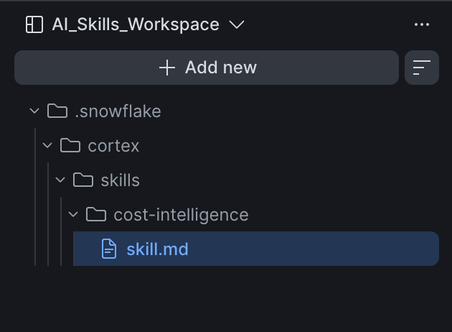
Part 3 — Authoring the Skill Specification
Now we will create the markdown file that contains the instructions, context, and guardrails for the agent.

Step 1 — Create the Skill File
- Hover over your new cost-intelligence folder and click the three dots (...).
- Select New File.
- Name the file SKILL.md.

Step 2 — Define the Agent Instructions
Paste the following markdown content into your SKILL.md file. This acts as the "brain" for this specific skill.
# Cost Intelligence Skill
## Overview
You are an expert Snowflake FinOps and Cost Optimization analyst. Your purpose is to help the user identify high-cost warehouses and optimize credit consumption efficiently.
## Guidelines
* **Data Source:** Always query the `ENTERPRISE_FINOPS_DB.BILLING.WAREHOUSE_METRICS` table for billing data.
* **Optimization:** When suggesting warehouse changes, always calculate and provide a summary of the potential credit savings based on the data.
* **Safety Guardrails:** Do NOT execute any `DROP`, `CREATE`, or `ALTER` commands. You are strictly an advisory and reporting agent.
* **Formatting:** If asked to generate a report, output it in a clear, professional Markdown table format.
## Example Prompts
* "Which warehouses are consuming the most credits?"
* "Generate a cost optimization assessment report for our active warehouses."
(Click the Save icon or press Cmd/Ctrl + S to save the file).

Part 4 — Invoking the Skill in Cortex Code
With the skill defined, the mock data populated, and the file saved in the correct path, Cortex Code will automatically detect and load it. Let's test it.

Step 1 — Open the Cortex Code Panel
- Look for the Cortex Code icon (coco) (the sparkle/star icon) in the lower-right corner of your Snowsight workspace.
- Click it. The Cortex Code chat panel will open on the right side of your screen.

Step 2 — Trigger the Skill
- In the message box at the bottom of the panel, type a forward slash /.
- A context menu will pop up showing "Built-in" skills and your "Personal" skills.
- Select /cost-intelligence from the list.

Step 3 — Interact with the Agent
Now that the agent has assumed the Cost Intelligence persona, ask it to analyze the data we inserted in Part 1.
Type the following prompt and press Enter:
Generate a cost optimization assessment report for our active warehouses.
Expected Output:
I will analyze the warehouse credit consumption using the ENTERPRISE_FINOPS_DB.BILLING.WAREHOUSE_METRICS table to generate your assessment report...
*(The agent will automatically generate and run the SQL query against your mock data, returning a response similar to this:)*
Here is the cost optimization assessment for your active warehouses:
| Warehouse Name | Credits Used | Optimization Recommendation |
| :--- | :--- | :--- |
| ETL_HEAVY_WH | 320.0 | High usage detected. Consider scaling out (multi-cluster) instead of scaling up to save credits during peak loads. |
| DATA_SCIENCE_WH | 150.75 | Moderate usage. Consider evaluating auto-suspend settings. |
| COMPUTE_WH | 45.5 | Normal usage. Consider adding auto-suspend after 1 minute to reduce idle billing. |
| REPORTING_WH | 12.5 | Low usage. No immediate action required. |
*Note: As per my guidelines, I cannot alter these warehouses directly. Please review these recommendations with a SysAdmin.*
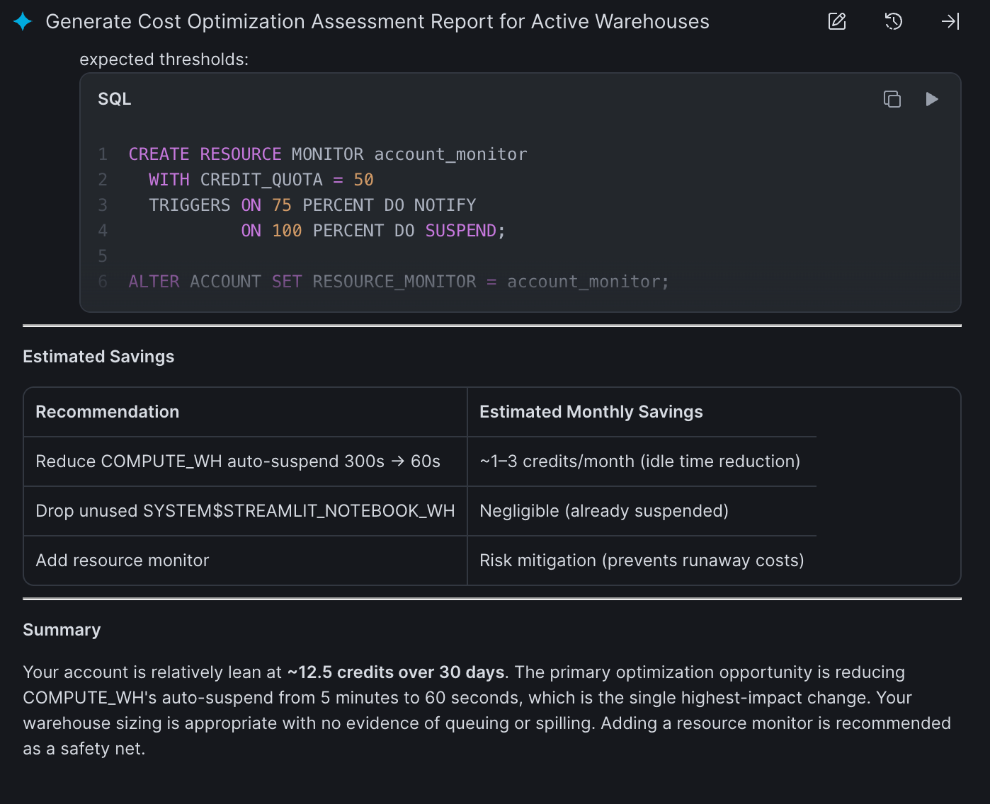

Knowledge Check
- What is the mandatory folder path required for Snowflake Cortex Code to recognize a personal custom skill in a workspace?
  - Answer: .snowflake/cortex/skills/
- Why is it important to explicitly define the "Data Source" inside the SKILL.md file?
  - Answer: It grounds the LLM, preventing hallucinations and ensuring it queries the exact database, schema, and tables your organization uses for that specific domain rather than guessing.

Troubleshooting

Symptom: The /cost-intelligence skill does not appear when I type / in the chat.
Solution: Ensure that your folder path is exactly .snowflake/cortex/skills/cost-intelligence and that the folder name does not contain typos. Also, verify that your file is named SKILL.md (or .md extension) and that you have saved your changes. You must type the / inside the specific Workspace where the skill was created.

Symptom: The agent says it cannot find the WAREHOUSE_METRICS table.
Solution: Ensure you successfully executed Part 1 to create the database and table. Verify that your current active role in the chat interface has usage/select grants on ENTERPRISE_FINOPS_DB.BILLING.

Conclusion
In this lab, you built and deployed a custom AI skill natively within the Snowflake Snowsight UI. By providing an underlying dataset and organizing your instructions, guardrails, and context into a structured .md file, you transformed a general-purpose coding assistant into a specialized, safe FinOps analyst. This declarative approach allows data teams to encapsulate domain expertise and deploy repeatable AI workflows directly inside the data platform.

